**1. INTRODUCTION**

* 1. **Project Overview**

Machine Learning (ML) is one of the most important and popular emerging branches these days as it is a part of Artificial Intelligence (AI). In recent times, machine learning becomes an essential and upcoming research area for transportation engineering, especially in traffic prediction. Traffic congestion affects the country’s economy directly or indirectly by its means. Traffic congestion also takes people’s valuable time, cost of fuel every single day. As traffic congestion is a major problem for all classes in society, there has to be a small-scale traffic prediction for the people’s sake of living their lives without frustration or tension. For ensuring the country’s economic growth, the road user’s ease is required in the first place. This is possible only when the traffic flow is smooth. To deal with this, Traffic prediction is needed so that we can estimate or predict the future traffic to some extent.

In addition to the country’s economy, pollution can also be reduced. The government is also investing in the intelligent transportation system (ITS) to solve these issues. The plot of this research paper is to find different machine learning algorithms and speculating the models by utilizing python3.The goal of traffic flow prediction is to predict the traffic to the users as soon as possible. Nowadays the traffic becomes really hectic and this cannot be determined by the people when they are on roads.

So, this research can be helpful to predict traffic. Machine learning is usually done using anaconda software but, in this paper, I have used the python program using command prompt window which is much easier than the usual way of predicting the data. In summary, the constructs of this paper consist of ten major sections. These are: Introduction, Purpose of Traffic Prediction, Problem Statement, Related Work, Overview, Methodology, Software Implementation and Conclusion with Future work.

* 1. **Purpose of the Project**

Many reports of the traffic data are of actual time but it is not favorable and ccessible to many users as we need to have prior decision in which route we need to travel. For example,

During working days, we need to have daily traffic information or at times we need hourly traffic information but then the traffic congestion occurs; for solving this issue the user need to have actual time traffic prediction. Many factors are responsible forthe traffic congestion. This can be predicted by taking two datasets; one with the past year and one with the recent year’s data set. If traffic is so heavy then the traffic can be predicted by referring the same time in the past year’s data set and analyzing how congested the traffic would be. With the increasing cost of the fuel, the traffic congestion changes drastically. The goal of this prediction is to provide real-time gridlock and snarl up information. The traffic on the city becomes complex and are out of control these days, so such kind of systems are not sufficient for prediction. Therefore, research on traffic flow prediction plays a major role in ITS.

**2. IDEATION PHASE**

2.1 Problem Statement

2.2 Empathy Map Canvas

2.3 Brainstorming

**3. REQUIREMENT ANALYSIS**

3.1 Customer Journey map

3.2 Solution Requirement

3.3 Data Flow Diagram

3.4 Technology Stack

**4. PROJECT DESIGN**

4.1 Problem Solution Fit

4.2 Proposed Solution

4.3 Solution Architecture

**5. PROJECT PLANNING & SCHEDULING**

5.1 Project Planning

**6. FUNCTIONAL AND PERFORMANCE TESTING**

6.1 Performance Testing

**7. RESULTS**

**7.1 Output Screenshots**

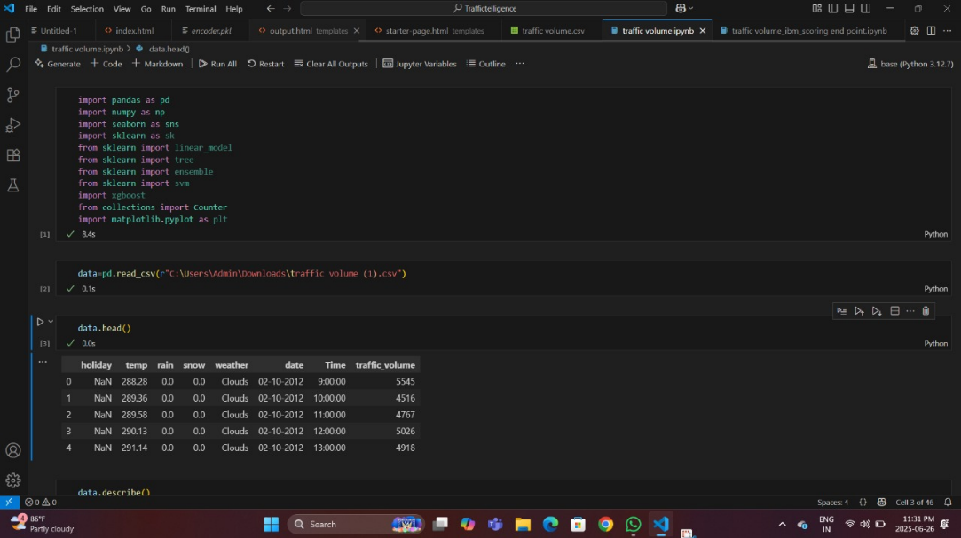

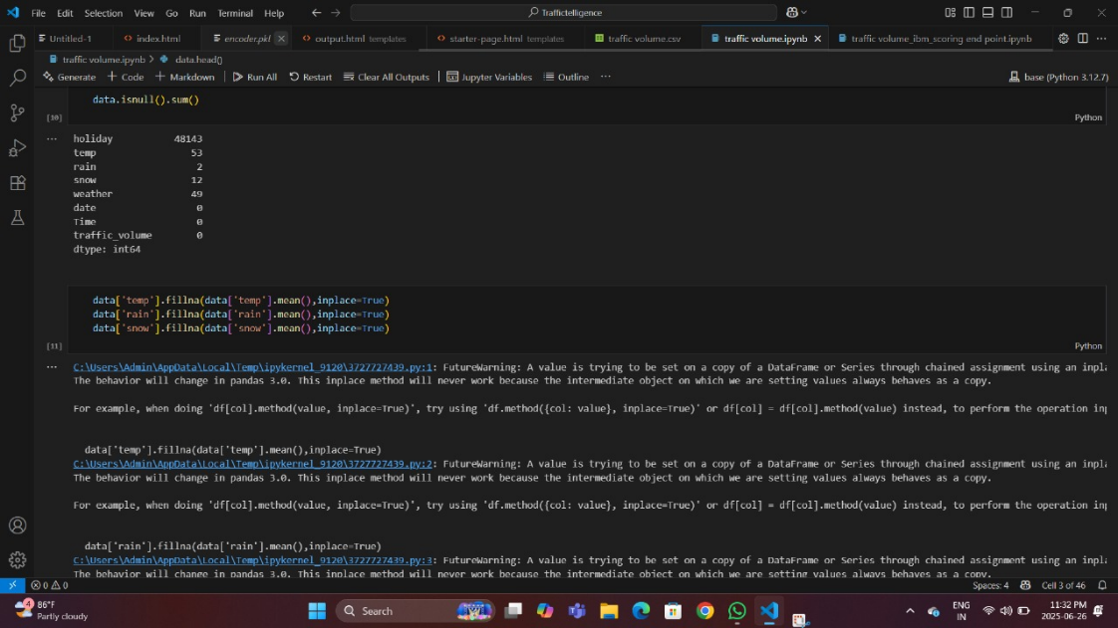

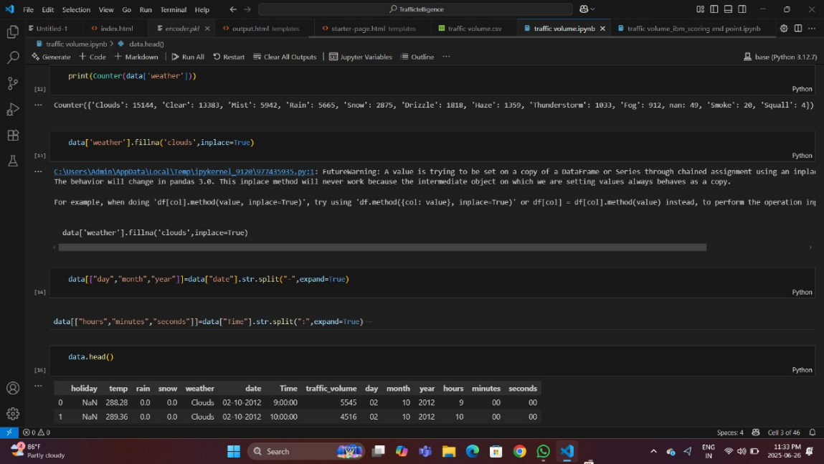

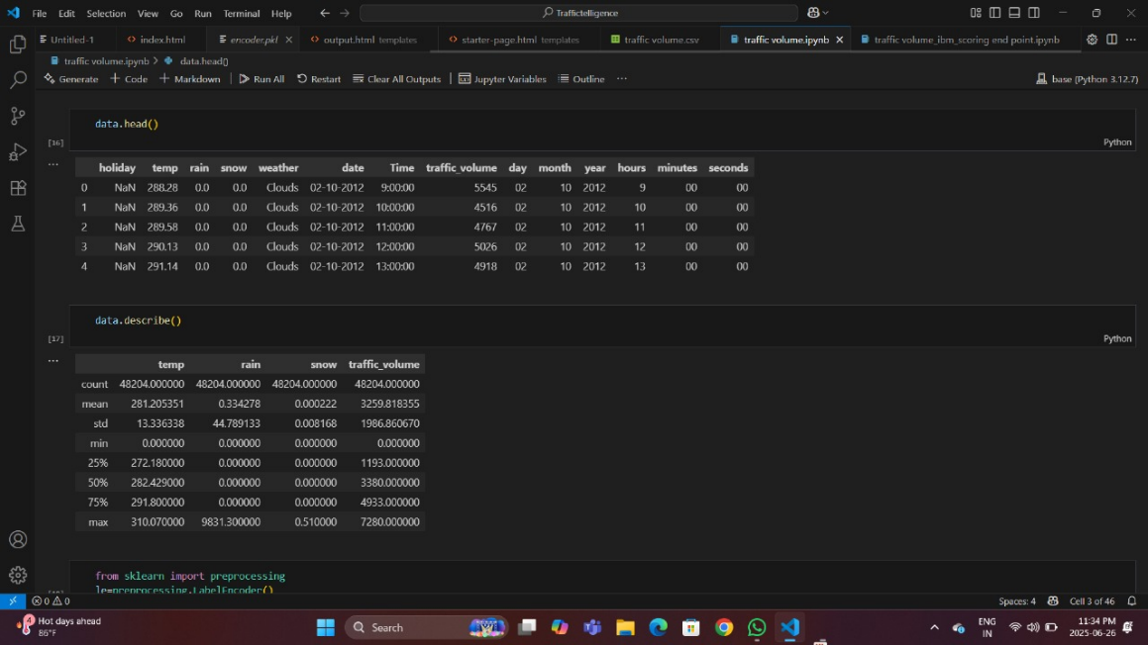

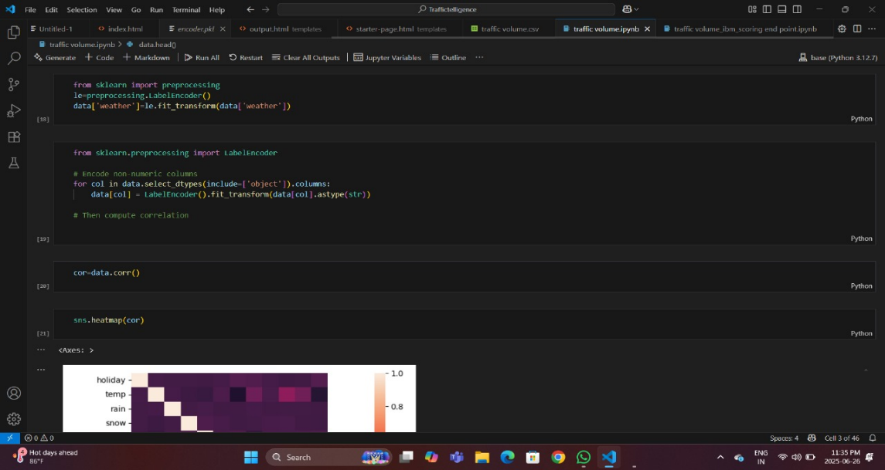

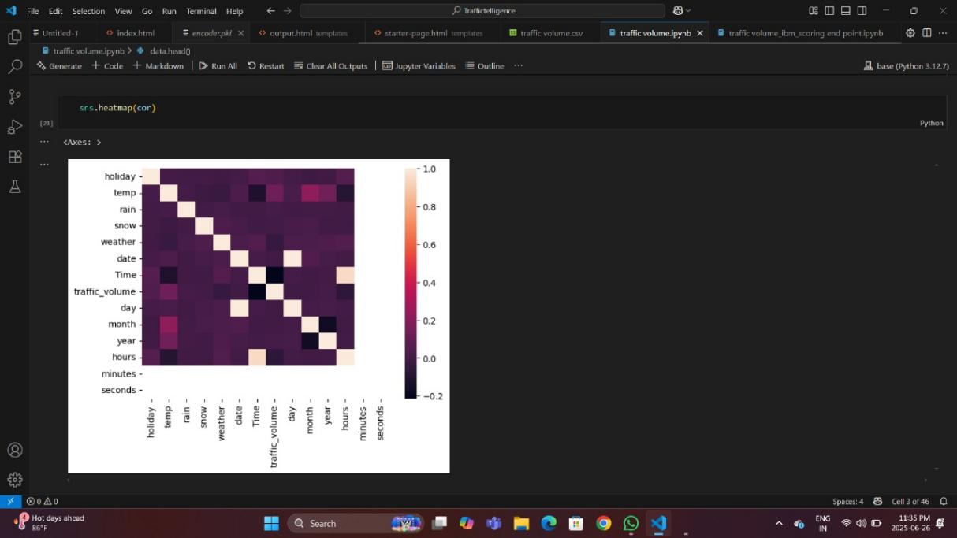

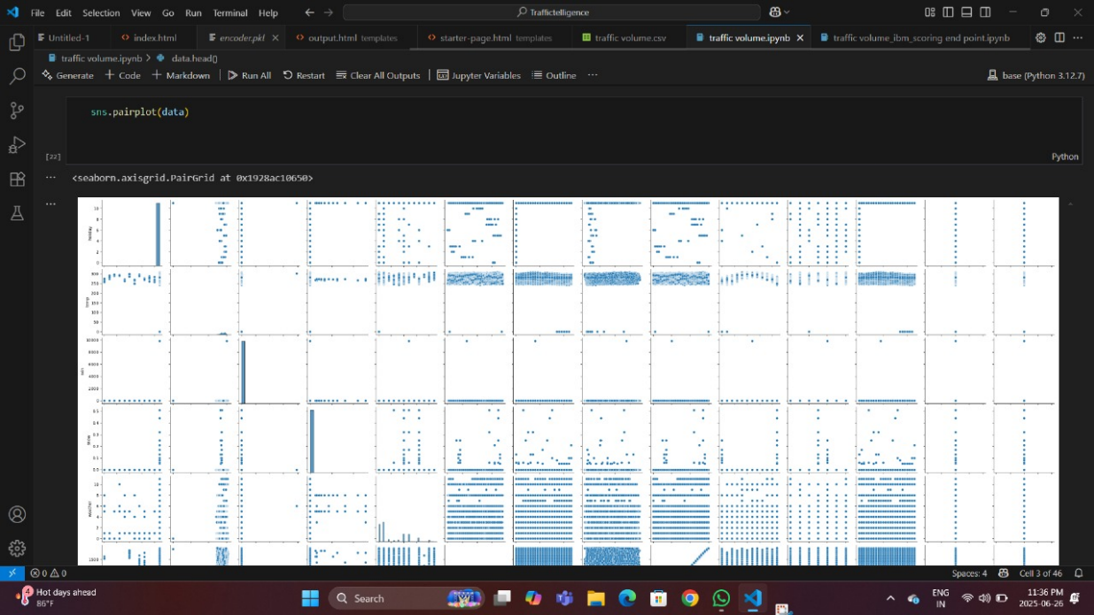

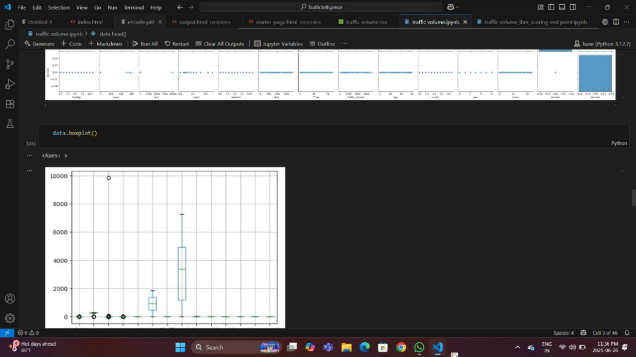

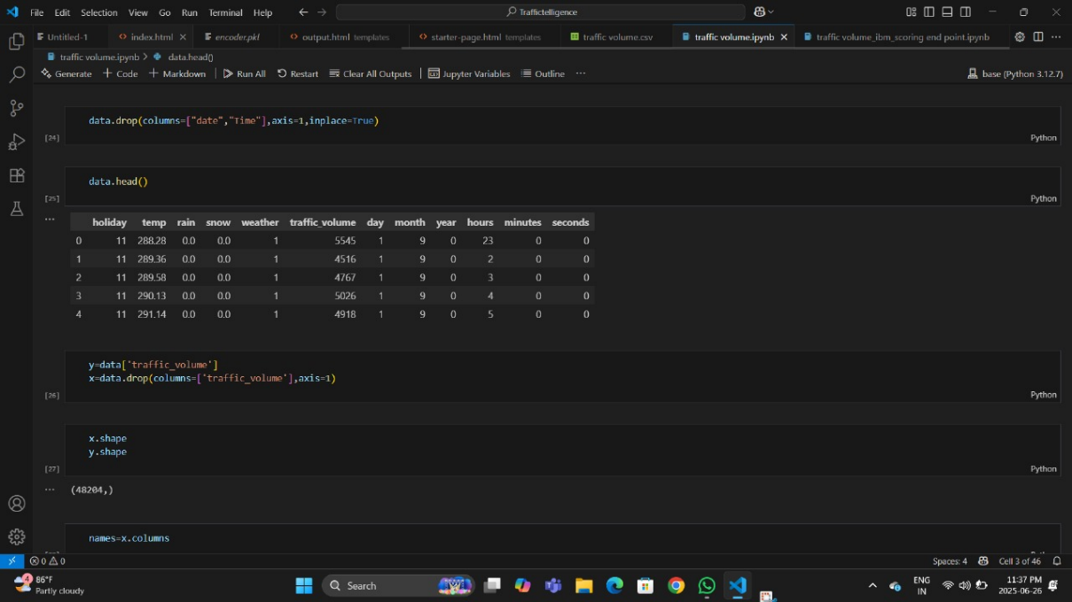

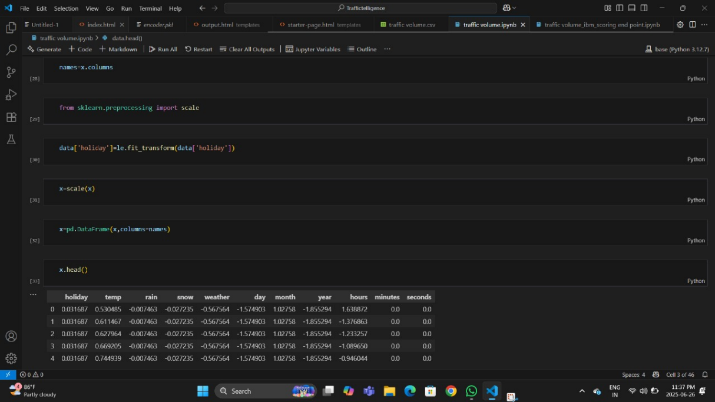

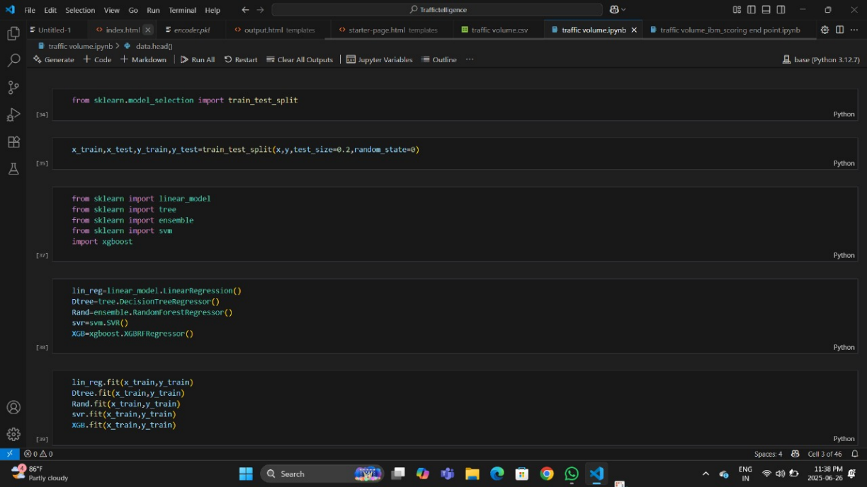

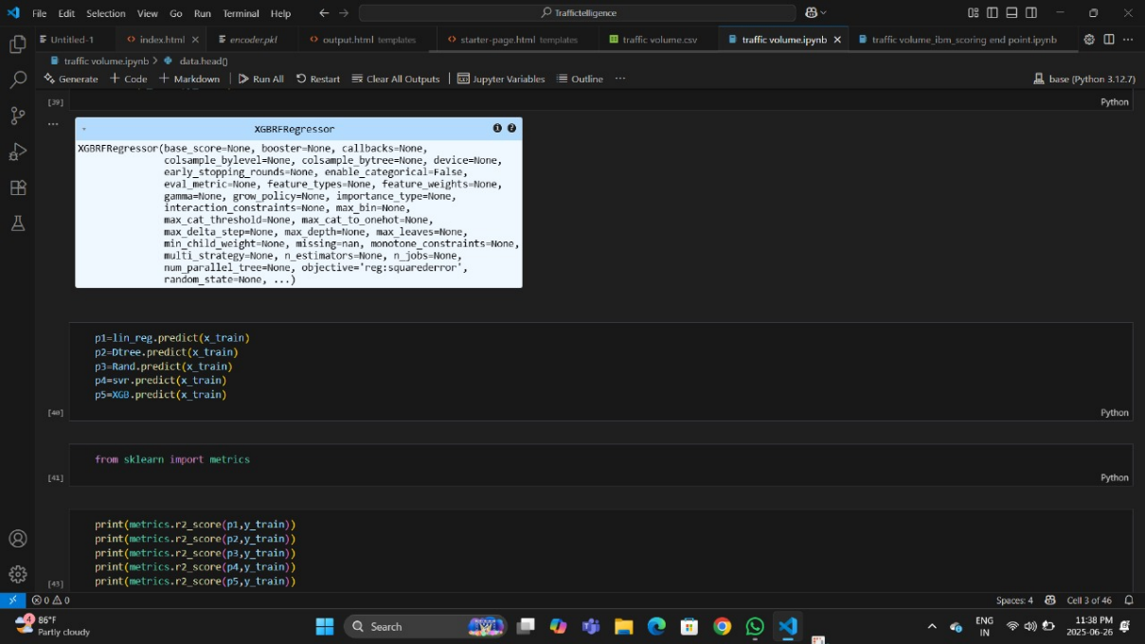

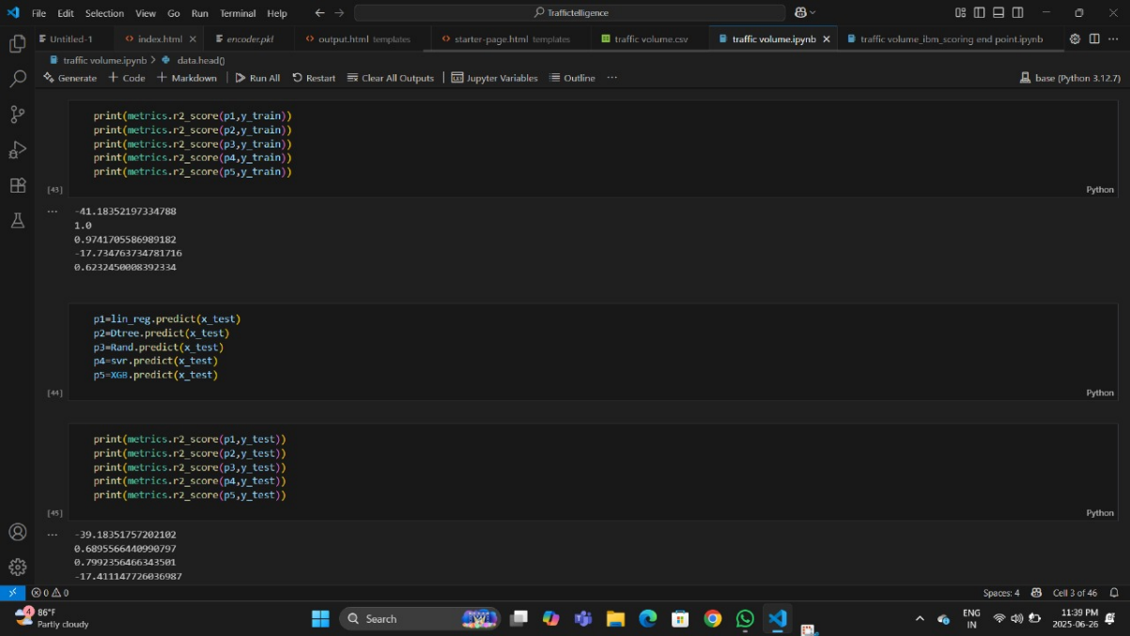

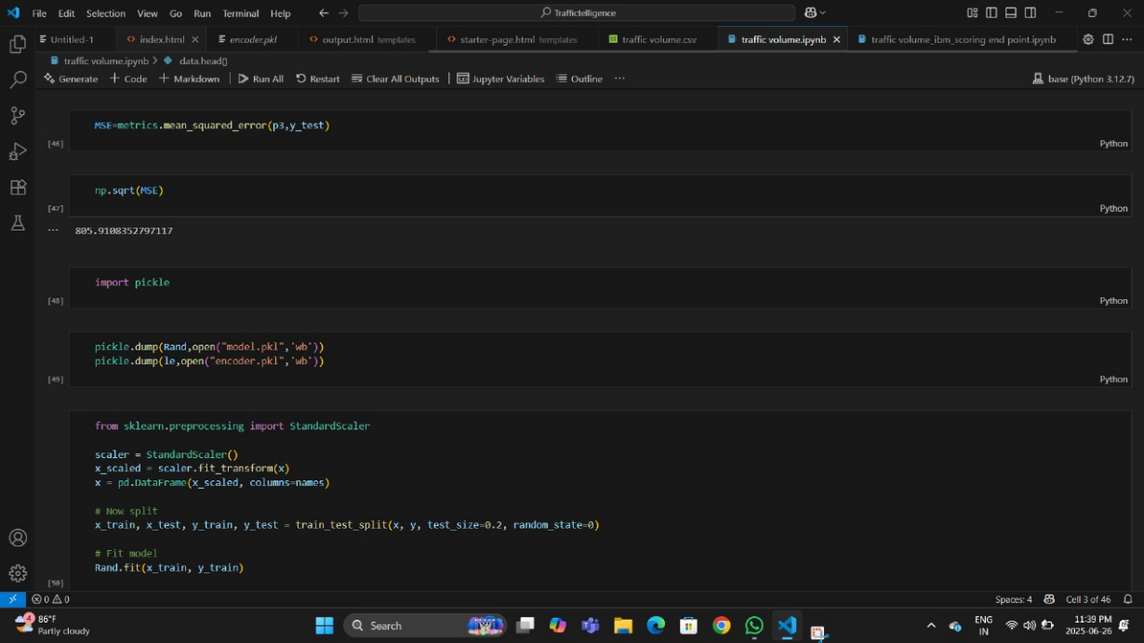

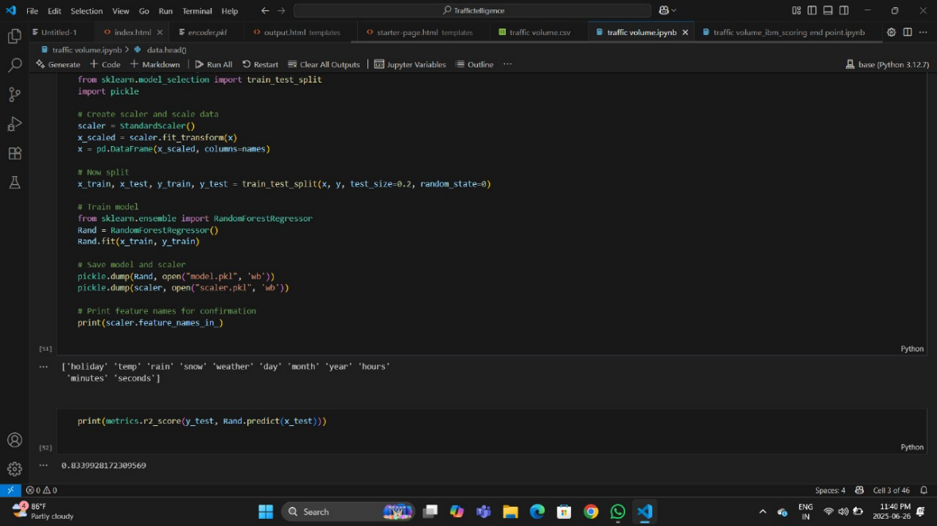

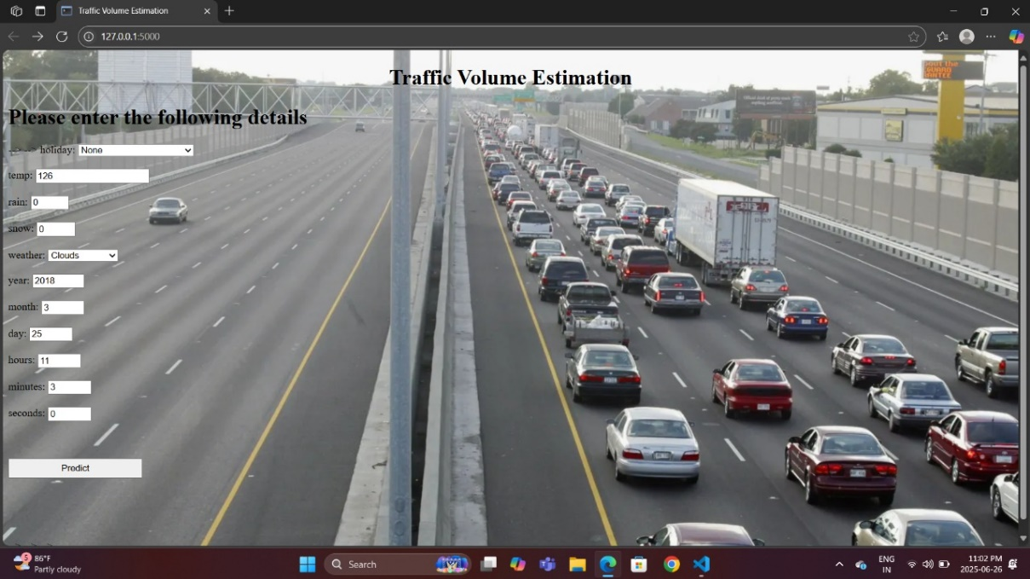



**8. ADVANTAGES & DISADVANTAGES**

**8.1 Advantages**

| **Advantage** | **Description** |
| --- | --- |
| **High Accuracy** | ML models can learn complex patterns and deliver more accurate traffic volume predictions than traditional methods. |
| **Real-Time Capability** | With proper integration of GPS, IoT, and streaming data, predictions can be updated in real-time. |
| **Scalability** | The system can be easily scaled to cover different cities or road networks by retraining or fine-tuning models. |
| **Cost-Effective Over Time** | Reduces the need for expensive physical infrastructure (e.g., loop detectors, manual counting). |
| **Data-Driven Decision Making** | Authorities can use insights from the model to improve traffic signal timings, road planning, and congestion control. |
| **Adaptability** | Can be retrained or updated based on changing traffic conditions, events, or new data sources. |

**Table 8.1: Advantages**

**8.2 Disadvantages / Limitations**

| **Disadvantage** | **Description** |
| --- | --- |
| **Data Dependency** | Requires large volumes of quality data (e.g., GPS traces, historical traffic) to train accurate models. |
| **Complexity in Implementation** | Integrating various data sources and building models requires technical expertise. |
| **Real-Time Infrastructure** | Real-time predictions need high-speed data processing pipelines and infrastructure, which can be costly initially. |
| **Model Interpretability** | Deep learning models (e.g., LSTM, GNN) may act as black boxes, making it hard to explain predictions. |
| **Generalization Issues** | A model trained for one city or area may not perform well in another without retraining. |

**Table 8.2: Disadvantages**

**9.CONCLUSION**

In the system, it has been concluded that we develop the traffic flow prediction system by using a machine learning algorithm. By using regression model, the prediction is done. The public gets the benefits such as the current situation of the traffic flow, they can also check what will be the flow of traffic on the right after one hour of the situation and they can also know how the roads are as they can know mean of the vehicles passing though a particular junction that is 4 here. The weather conditions have been changing from years to years. The cost of fuel is also playing a major role in the transportation system. Many people are not able to afford the vehicle because of the fuel cost. So, there can be many variations in the traffic data. There is one more scenario where people prefer going on their own vehicle without car-pooling, this also matters in the traffic congestion. So, this prediction can help judging the traffic flow by comparing them with these 2 years data sets. The forecasting or the prediction can help people or the users in judging the road traffic easier beforehand and even they can decide which way to go using their navigator and also this will prediction will be also helpful.

**10. FUTURE SCOPE**

In the future, the system are often further improved using more factors that affect traffic management using other methods like deep learning, artificial neural network, and even big data. The users can then use this technique to seek out which route would be easiest to achieve on destination. The system can help in suggesting the users with their choice of search and also it can help to find the simplest choice where traffic isn't in any crowded environment. Many forecasting methods have already been applied in road traffic jam forecasting. While there's more scope to create the congestion prediction more precise, there are more methods that give precise and accurate results from the prediction. Also, during this period, the employment of the increased available traffic data by applying the newly developed forecasting models can improve the prediction accuracy. These days, traffic prediction is extremely necessary for pretty much a part of the state and also worldwide. So, this method of prediction would be helpful in predicting the traffic before and beforehand. For better congestion prediction, the grade and accuracy are prominent in traffic prediction. within the future, the expectation are going to be the estimation of established order accuracy prediction with much easier and user-friendly methods so people would find the prediction model useful and that they won’t be wasting their time and energy to predict the information. There will be some more accessibility like weather outlook, GPS that's the road and accident-prone areas will be highlighted in order that people wouldn't prefer using the paths which aren't safe and simultaneously they'll predict the traffic. This will be done by deep learning, big data, and artificial neural networks.

**11. APPENDIX**

**Source Code:**

All codes are submitted in Git-Hub Repository

**Git-Hub Repository Link:**

[**https://github.com/Sireesha992/Traffictelligence-Advanced-Traffic-Volume-Estimation-With-Machine/tree/main**](https://github.com/Sireesha992/Traffictelligence-Advanced-Traffic-Volume-Estimation-With-Machine/tree/main)

**Dataset Link:**

[**https://drive.google.com/file/d/1AAvFlqZfhti5GhotjYfoXJ6beOEbckpM/view?usp=drivesdk**](https://drive.google.com/file/d/1AAvFlqZfhti5GhotjYfoXJ6beOEbckpM/view?usp=drivesdk)

**Project Demo Link:**

<https://drive.google.com/file/d/19xI-ej1W4tuvOWGD6MYk3hHvjFtnxmjP/view?usp=drivesdk>